Bipedal Humaoid Robot

Documentation of CAD Creation and 3D Printing

Portland State University

Agile and Adaptive Robotics Laboratory

Contents

Overview 2

Plotting XYZ Cloud Points 2

Ilium (and Sacrum) 3

Vertical Cut CAD Model Details 3

3D Printing Vertical Cut Model 4

Previous Methods and Ideas 6

Sacrum 8

Sacrum CAD Model Details 8

3D Printing the Sacrum: 8

Femoral Head and Ball 9

CAD Modeling Design 9

3D Printing the Femoral Head and Ball 10

Assembly 11

# Overview

This document overviews the process of redesigning a pelvis for the Bipedal Humanoid Robot. Alex Steele’s Model was initially referenced for ideas and problems that arose with his model were overcome. This redesign would focus on

1. Building the CAD models in a professional, well maintained, easy to understand way
2. Allowing for muscle attachment points to be easily placed by building parts in the same XYZ location as the OpenSim 4.0 Model.
3. Change the method of attaching the femoral head to avoid using a BPA muscle.
4. Designing the parts for additive manufacturing

## Plotting XYZ Cloud Points

How to take a excel file with XYZ points from OpenSim4.0 and plot them in SolidWorks

1. Log into PSU Lab SolidWorks
2. Open excel file where points are stored
3. Convert them to mm filling in the first 3 columns
4. Save as ‘Formatted Text’ Space delimited File
5. Open in the .prn file in notepad
6. Save as a .txt file
7. Select SolidWorks Add-Ins and Click ‘ScanTo3D’
8. Press ‘File’ -> ‘Open’
9. Select file type ‘ScanTo3D Point Cloud Files’’
10. Find .Txt Document File
11. Press Open
12. Confirm length is correct by measuring
13. Create a 3D sketch
14. Select the point tool
15. Start clicking away at the point cloud points
16. Exit 3D sketch
17. Delete the Point Cloud

# Ilium (and Sacrum)

## Vertical Cut CAD Model Details

This SW part is built as if it were an assembly enabling the ‘.sldprt’ file to contain both the Ilium and the Sacrum. This was done in order to allow the interface between the Ilium and sacrum to be modeling better and allow the transition to connect seamlessly. This section will cover the design of the Ilium and information on the sacrum will be slightly covered. More information about the sacrum will be described in the ‘Sacrum’ section.

The SW part first begins with building the right ilium in one pieces and later splits the right ilium in 2 to allow the parts to be printed. For more details on why the ilium was split in 2, refer the ‘Previous Methods and Ideas’ subsection.

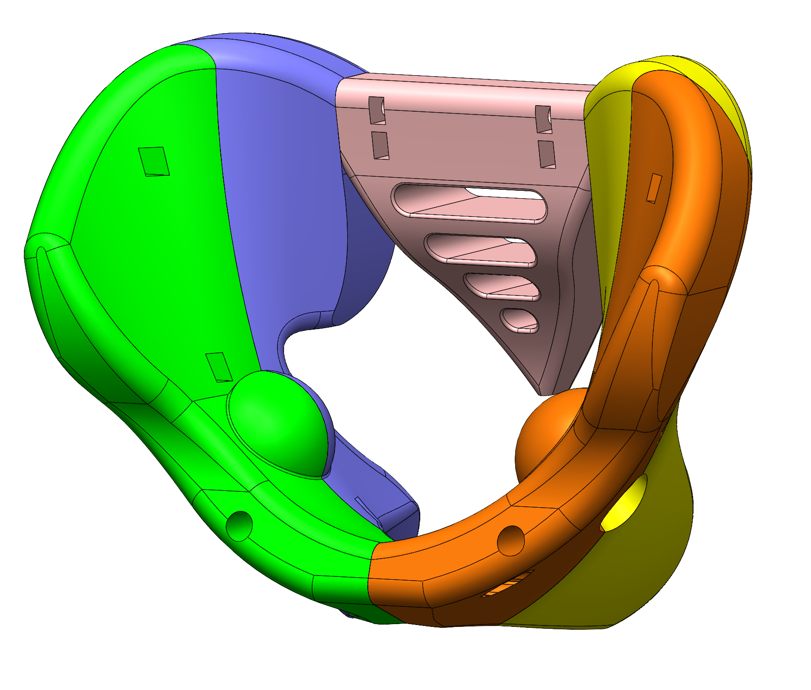

Steps to building the SW CAD model are below. We begin by building the right ilium, then the sacrum, and then mirroring the right ilium to the left.

1. The ilium and sacrum XYZ points were imported into a new SW part.
   1. See Section ‘Overview’, subsection ‘Plotting XYZ Cloud Points’ on details of how to plot XYZ points from an excel file
2. Sweep1 and then Sweep 2 are initialized to create a general ilium shape which will be ‘cut’ to shape later.
   1. Notice the that sweeps and sketches were done arbitrarily by trying to match the resulting shapes to closely follow the imported XYZ points and the general organic ilium shape that was desired
3. Then the general Sacrum shape is extruded
   1. Here it is important the make sure the ‘merge results’ box is NOT checked. This will create multiple bodies in the part file.
4. The ilium is then cut in the Right, Front, and Top planes to create the ilium shape that follows the XYZ point as well as a transition to the Sacrum
5. The Sacrum is then cut following the XYZ points and creating a nice connection to the ilium
6. The socket is then created in the ilium that will hold the femoral head. This socket I located near the socket in the OpenSim model where we see slightly more dense XYZ points.
7. The Ilium cut plane is created and is located at the center of the socket
8. Bolt and nut holes are created to connect 2 parts of the ilium together
   1. Note that the different actions to do this are located inside of a folder
9. The connection of right ilium to the left ilium is created in the pubis area.
   1. The hole that is created for this is made to allow the bolt head to be inserted and the hex nut as well. This allows us to mirror the right ilium without making any changes
10. Finishing touches like fillets are added to the ilium
11. Finishing touches like fillets are added to the sacrum
12. Now the ilium is cut into 2 parts by doing a cut extrude and making the distance negligibly small.
13. A mirror of the right ilium is performed
14. The bodies can now be saved individually for printing, see the next section for details.

## 3D Printing Vertical Cut Model

#### Preparing the STL file

At this point the Sacrum and the 2 part ilium are saved in one ‘sldprt’ file. We can export an individual file for each one.

1. Open to the ‘sldprt’ file where the sacrum and both sides of the ilium are built.
2. In the navigation tree, expand the ‘Solid Bodies’ node.
   1. There should be 5 parts in here as seen here:
   2. 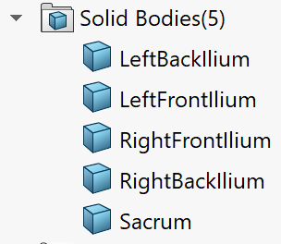
3. Right click on ‘Solid Bodies’ and click on ‘Save Bodies’
4. Select all the bodies that you want to save individually,
   1. If all 5 need to be saved, select all of them like this:
   2. 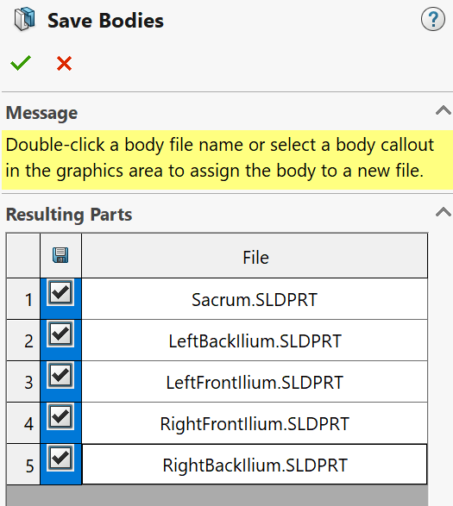
5. At this point it might ask for a file name and location, or it might save it to the same directory that you are working in.
6. Once all are checked, click the green check in the upper left.
7. At this point, check the folder where the files were saved.
   1. Note that these parts will be referencing the original ‘assembly part’ and might update automatically as the main file changes.
8. Those files can now be opened and then the STL file can be saved and used for 3D printing.

#### Right Front Ilium

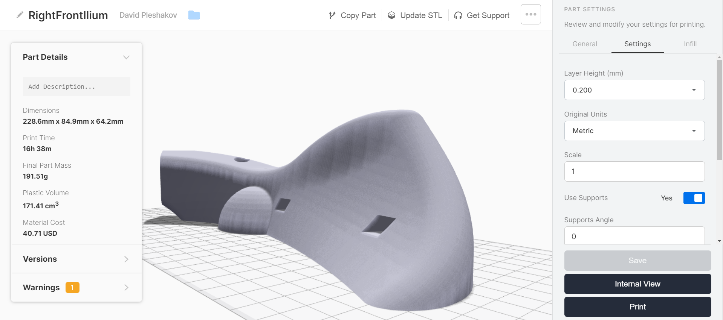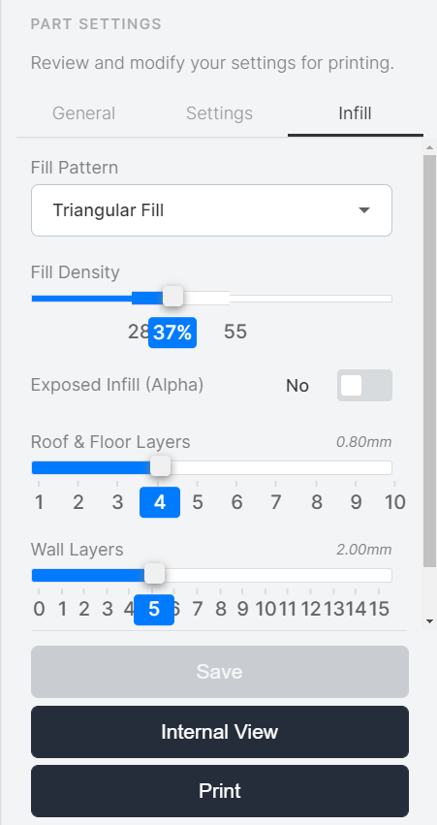

#### Right Back Ilium

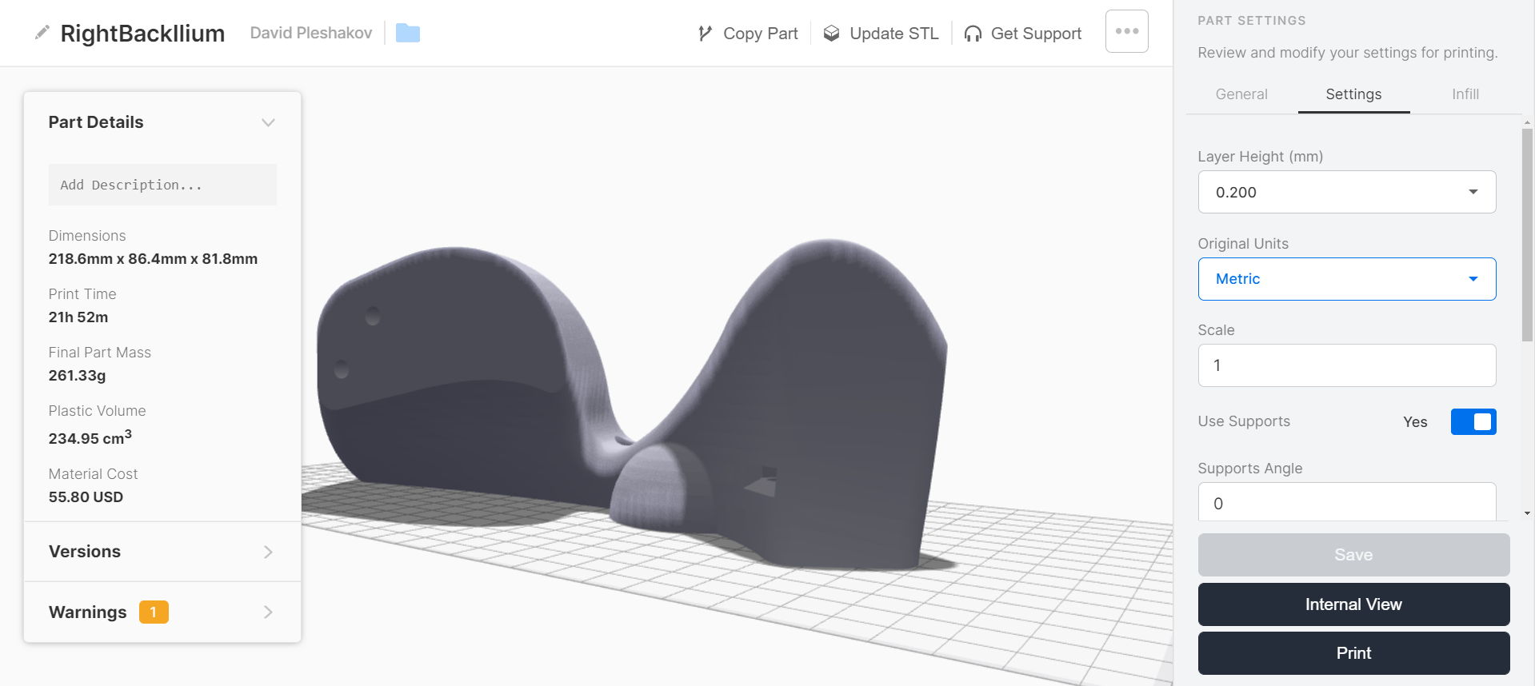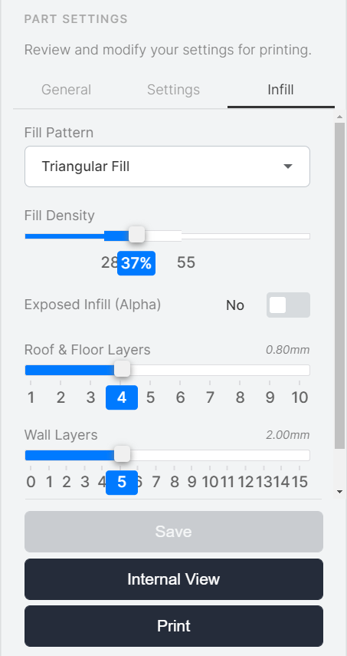

## Previous Methods and Ideas

#### Ilium with Cover Model (Cover Ilium)

The Cover Ilium model was the previous(older) model that was designed. Building and partially 3D printing this model gave a lot of insight to problems and best practices to keep in mind when building the hips.

Definition - Skeleton File: A base file with the main sketches that are referenced by other parts to make cuts and extrusions. These sketches can be adjusted and will be updated throughout all other referenced parts. Skeleton files were initially used for Cover Ilium, however, due to problems with external references, broken links when using ‘save as’, and complex sketches in the skeleton file, this method will not be used for building the pelvis.

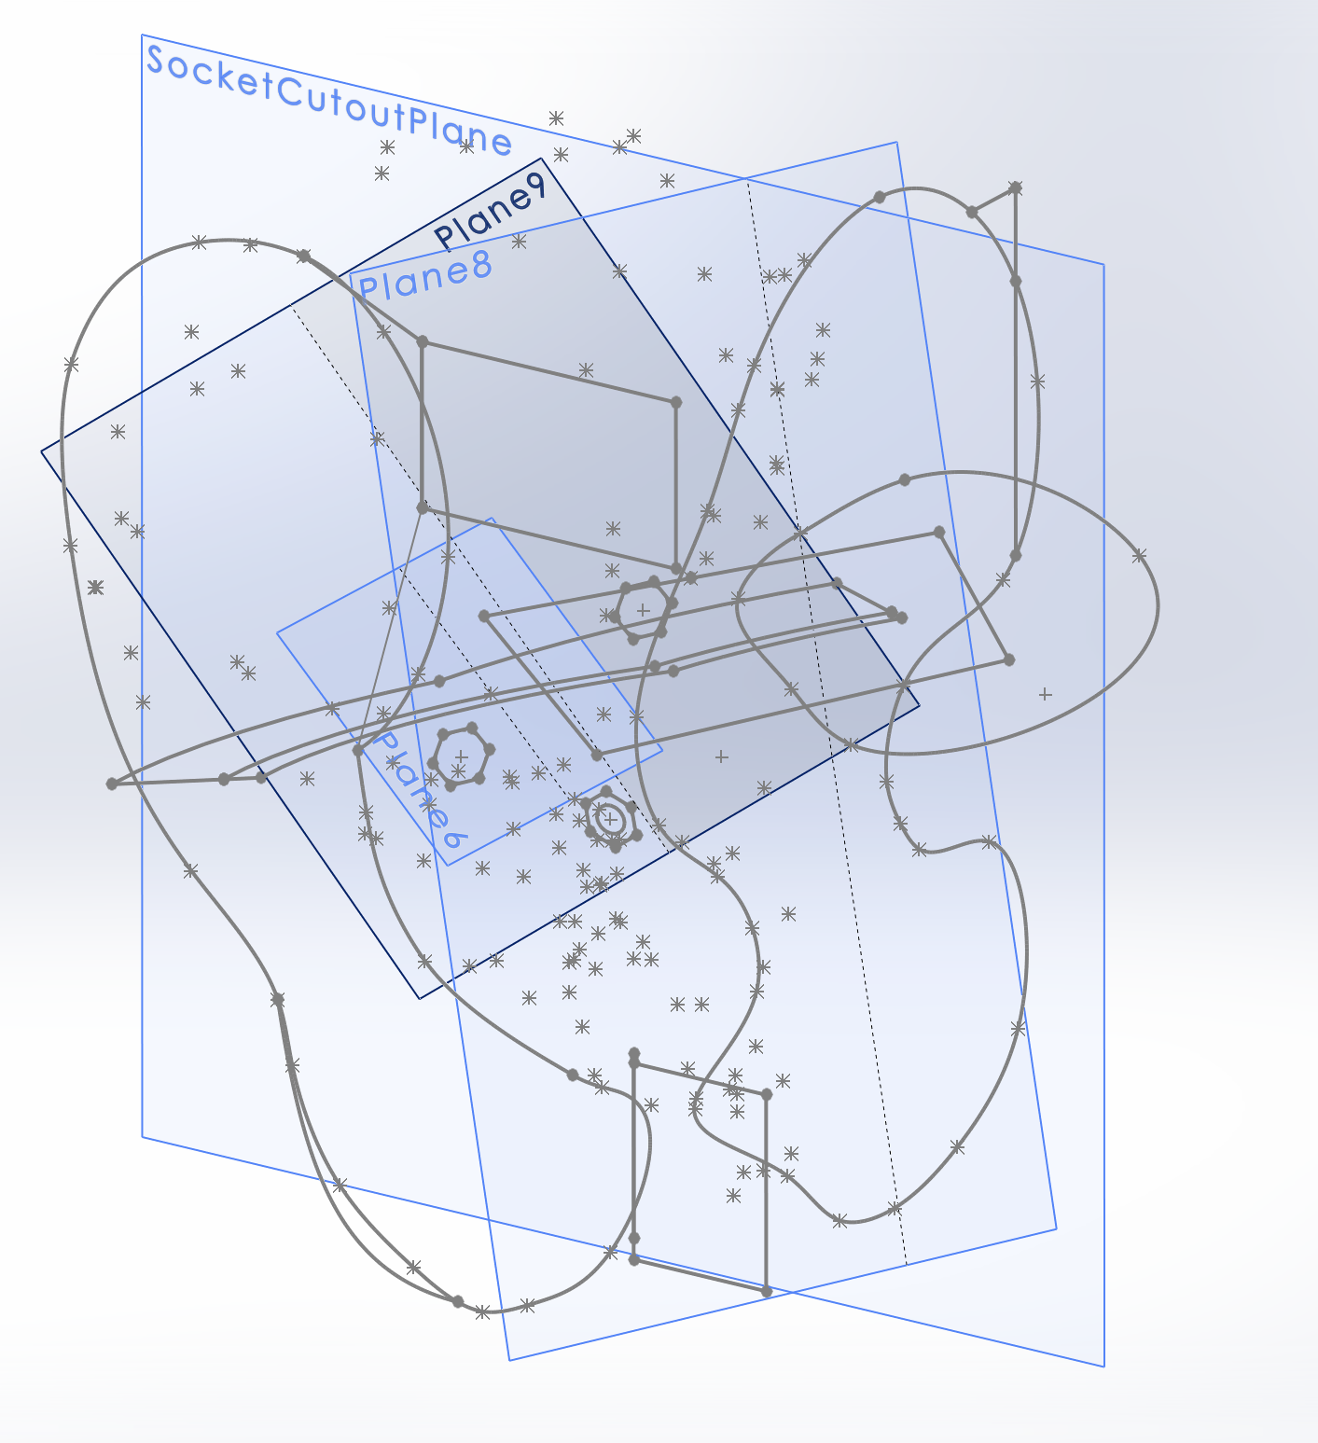

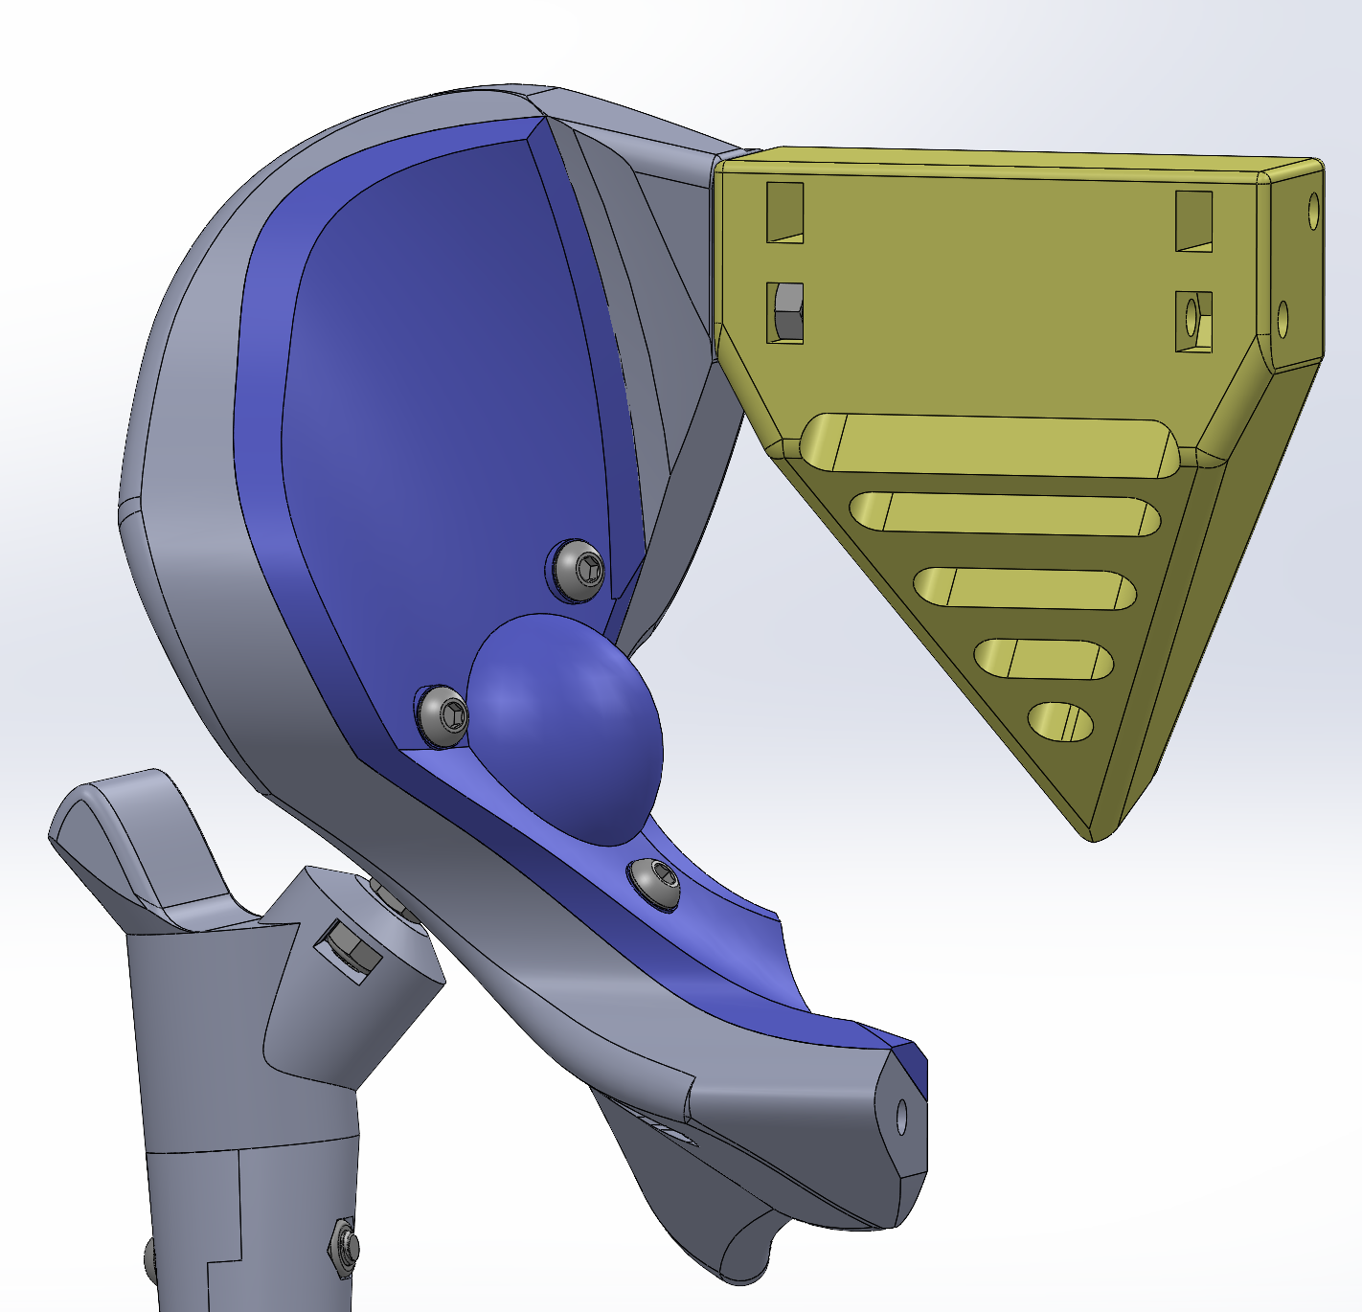

Cover Ilium was built using a cover plate and a socket cutout for the femoral head. This model also used an external skeleton file to build the part, as mentioned above. The ilium cover plate and the ilium base both referenced a third skeleton file which contained the critical sketches and dimensions.

Using the model described above, the Ilium was printed 2 times and failed twice in the same location as seen below



The print failed twice at the overhang where the plastic lifted up and the extruder caught onto it and pulled part off the bed as well as shifted the extruder.

In conclusion, it was decided the printing the ilium full size was not ideal, but instead it would be better to split it in half which would result in the following benefits:

1. Easier to 3D printing and orient
2. Less printing time per part and therefore less chance of failure
3. No need for a cover plate since ball can be inserted before connecting the 2 pieces of the ilium
4. Potential weaker ilium structure if ilium pieces are not connected correctly. (Negative effect)

#### Splitting the Ilium In Half - Horizontal

1. Splitting the ilium in half will allow the part to be printed easier
   1. The ilium needs to be rigid since muscle connection are located throughout the ilium
   2. Placing bolts to connect 2 ilium pieces is a bit awkward due to the shape of the ilium
   3. Dowel pins can be placed to make the connection stronger
   4. Consideration of how to split the part.
      1. Horizontal - 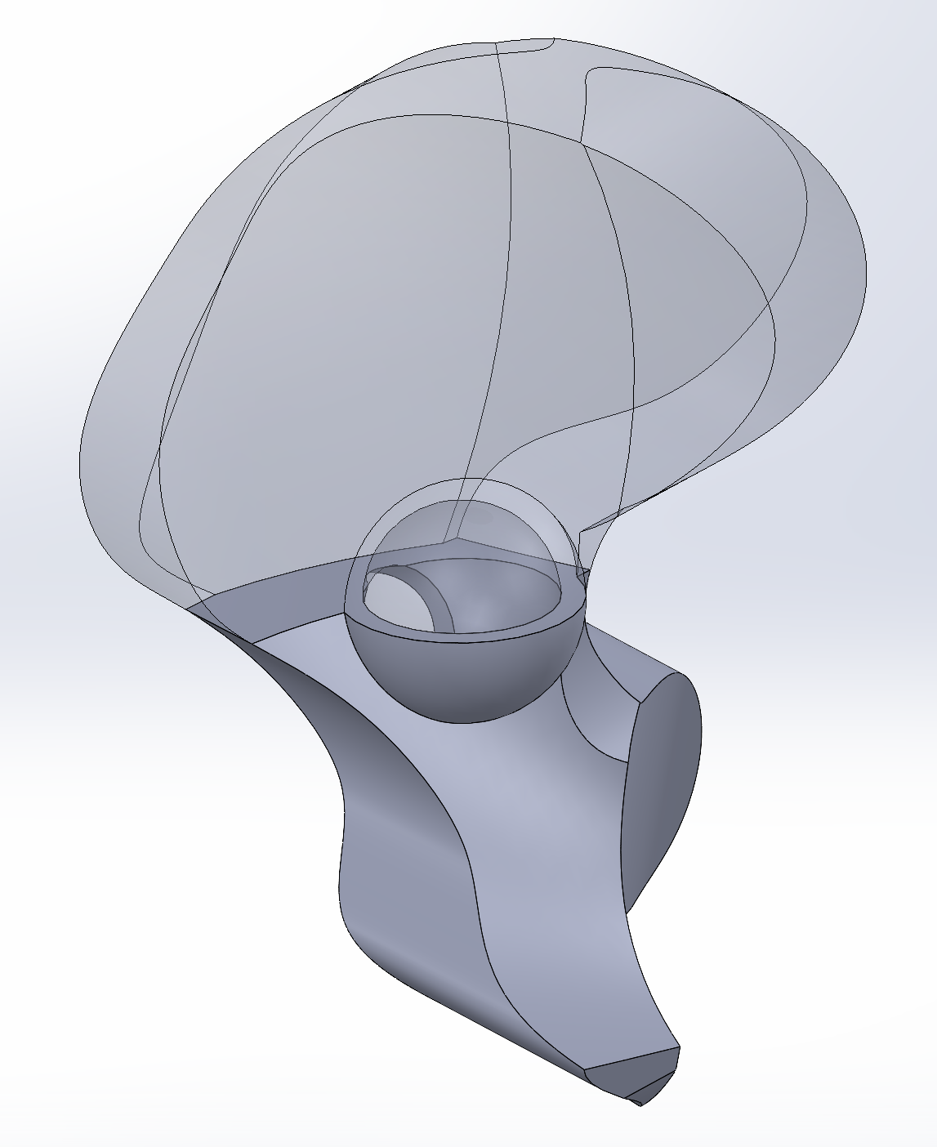
         1. Allows ball to be placed without a need for a cover
         2. Hard to connect the 2 parts since there is a small cross sectional area
      2. Vertical
         1. Easier to connect the 2 pieces together. See the main final version of the ilium for more details.

# Sacrum

## Sacrum CAD Model Details

1. This is continuation of some details described in the ‘Ilium’ section above
2. XYZ points plotted from OpenSim4.0 within the ilium model to allow for better design
3. Most parameters were based off of the imported points. This was done by making the general shape of the ilium and then making cuts that followed the OpenSim points as well as made it possible to connect to the ilium
4. The cutouts in the sacrum were made to decrease material usage and 3D printing time.

## 3D Printing the Sacrum:

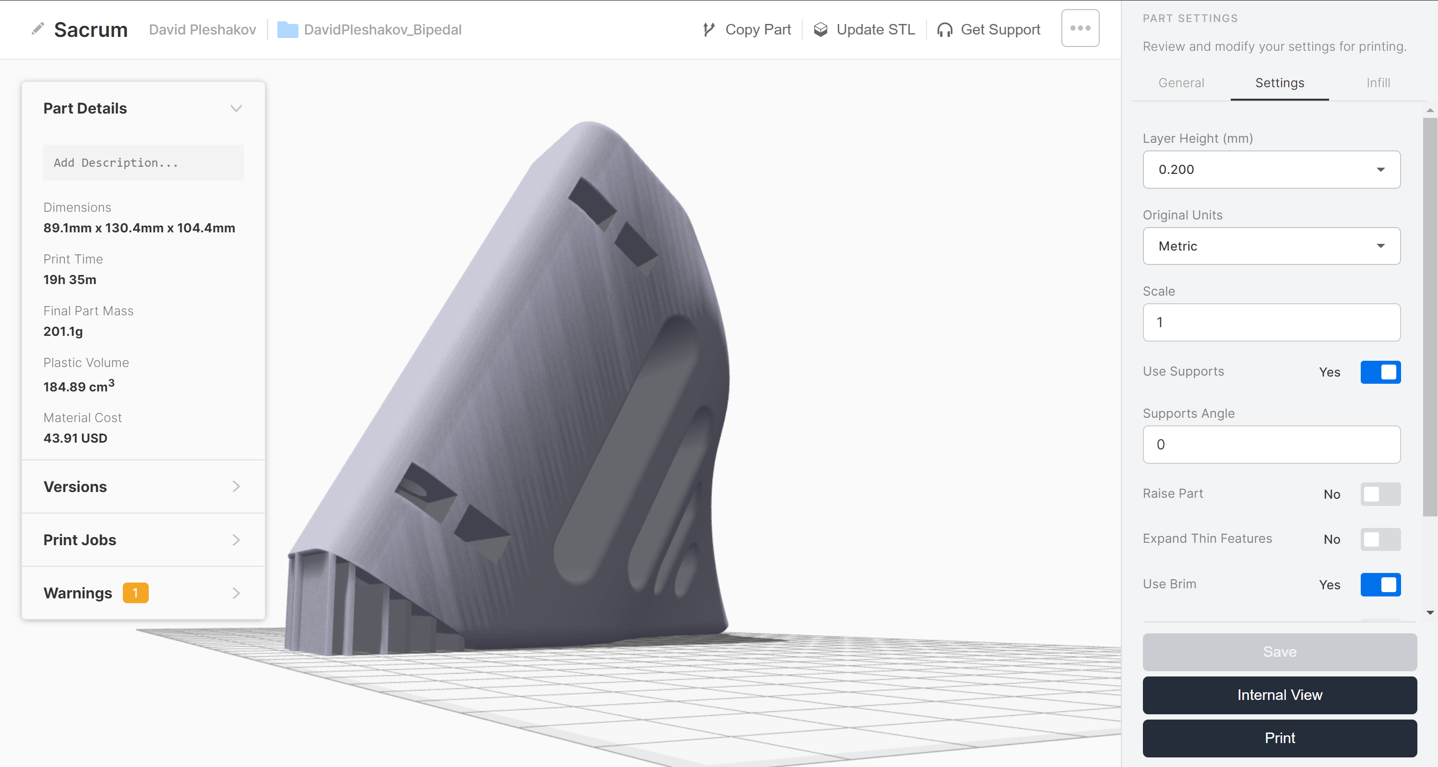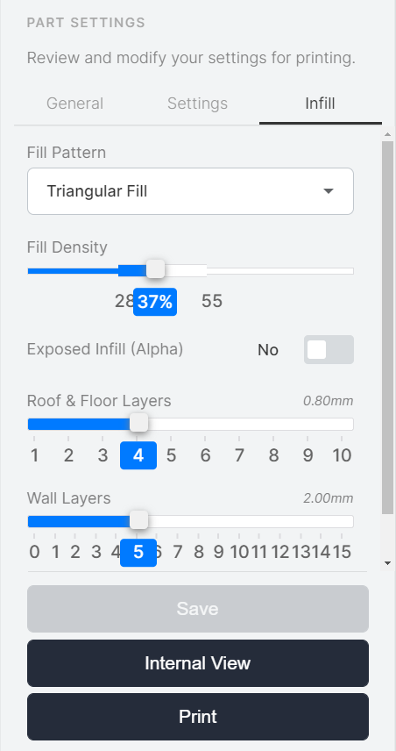

Notes: The exported 3D printing model of the sacrum was modified in order to add manual supports to the part. This was done because the printing kept failing due to poor support application of the Eiger software. Adding this support allows the sacrum to print without the edge warping leading to failure.  
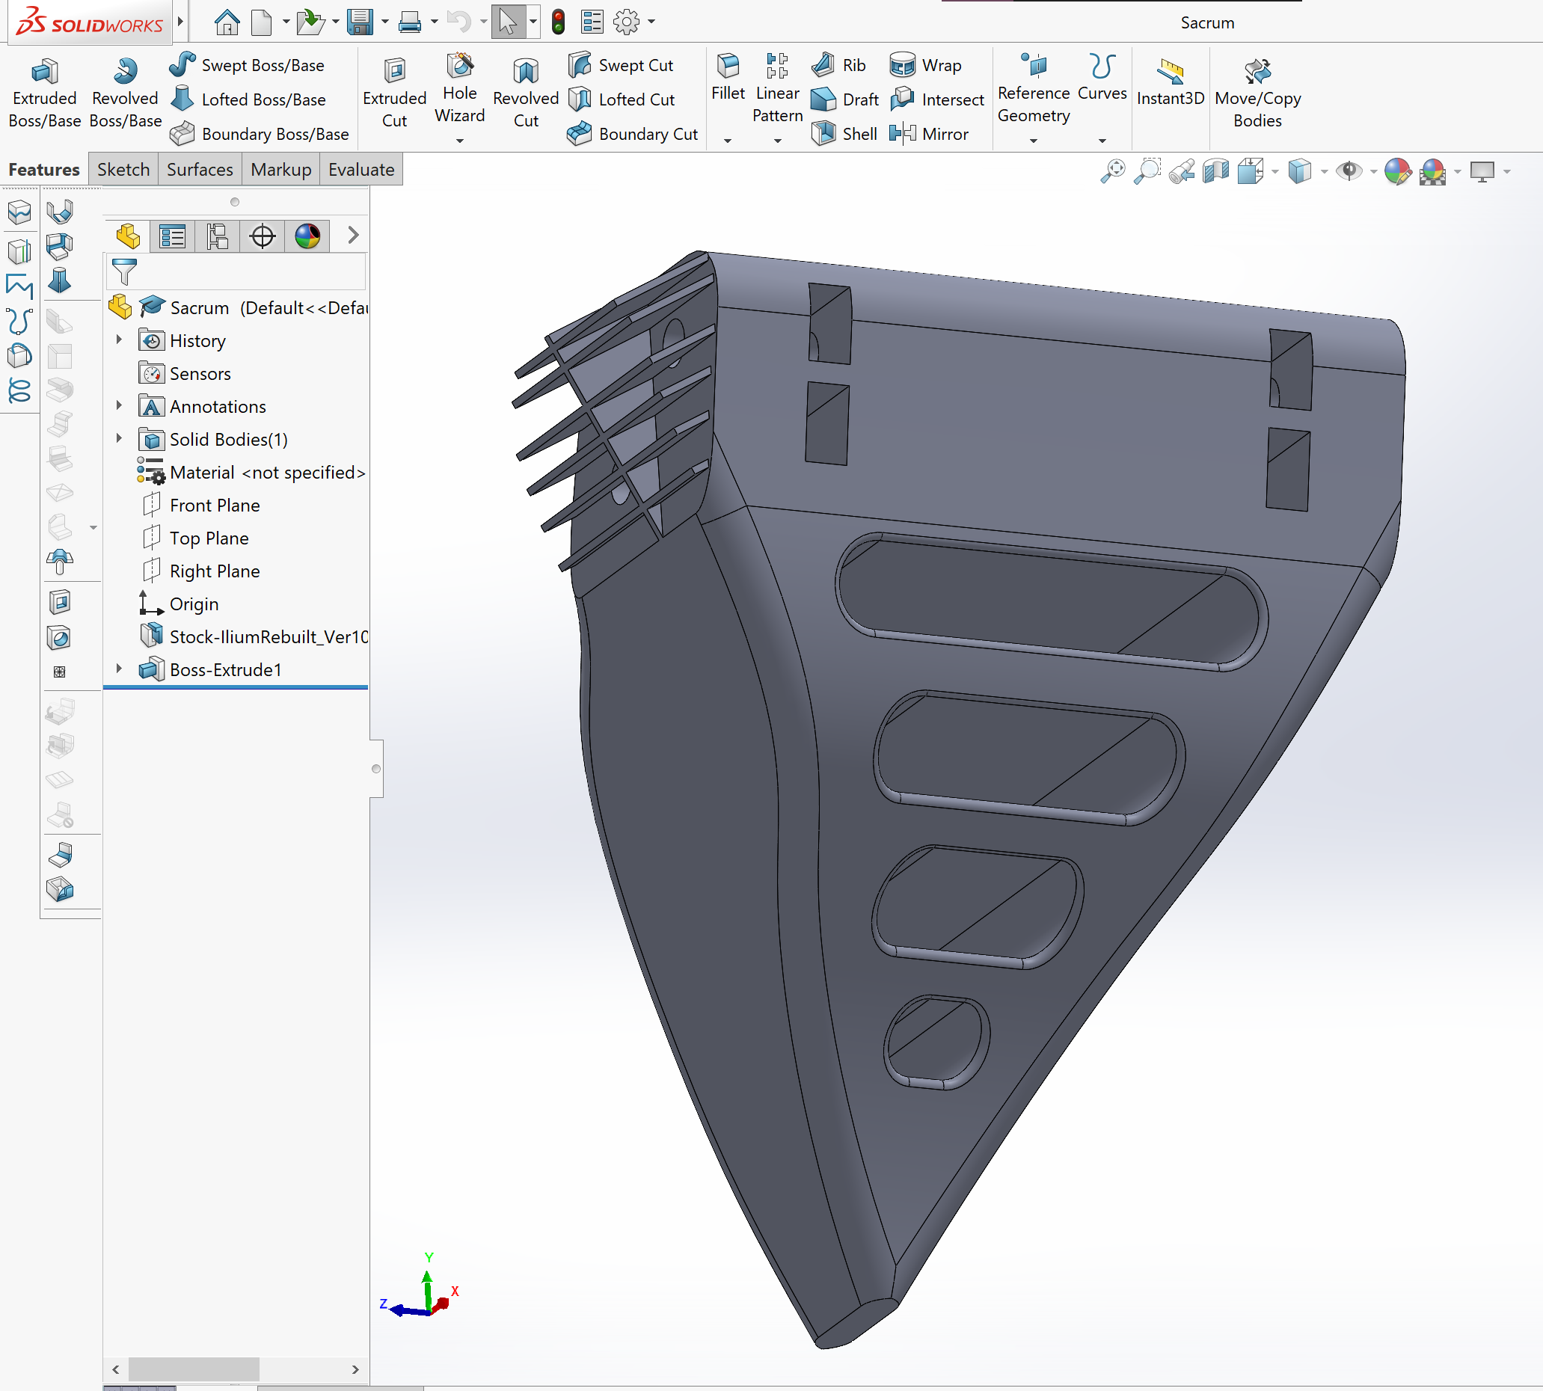

# Femoral Head and Ball

## CAD Modeling Design

The femoral head and ball was designed in multiple pieces to ensure that:

1. The ball can be printed separately so that size and tolerances can be easily changed and part quality can be easily increased without adding printing time to other components
   1. This will be done when testing how well the ball slides in the socket. Adjustments will need to be made to increase or decrease friction and other parameters.
2. A bolt can be used as the neck connecting the ball to the rest of the femur. This keeps the neck thin but still really strong removing concerns for the neck breaking.

The ball has a cutout for a hex bolt to slide into and then a cover to lock the bolt in and keep it in place.

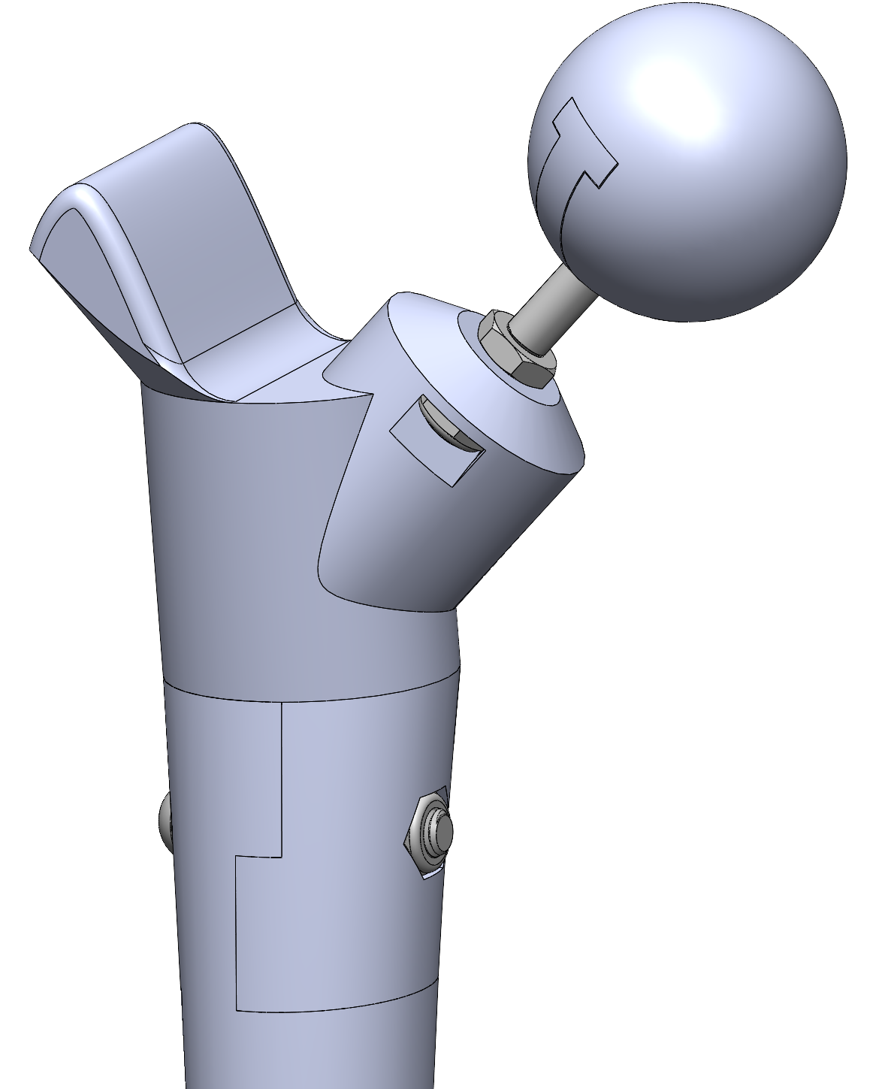 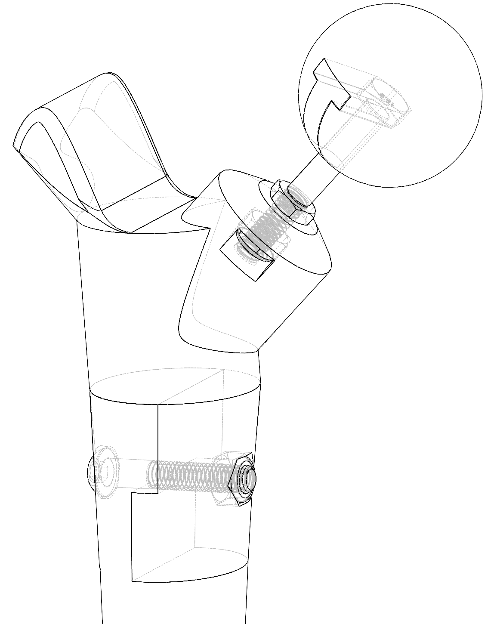

## 3D Printing the Femoral Head and Ball

 



# Assembly

The assembly of the hips occurs after printing all the necessary parts and having the correct hardware available for the designed parts. Below is the Bill of Materials for the Hips:

## Bill of Material

|  |  |  |  |
| --- | --- | --- | --- |
| **Part** | **Usage** | **McMaster Part #** | **Link** |
| Button Head Screw | Connecting various parts | 91239A330 | [Link](https://www.mcmaster.com/91239A330/) |
| Locknut | Nut for screw, nylon resists loosening | 94645A205 | [Link](https://www.mcmaster.com/94645A205/) |
| Thin Hex Nut | Used for the tightening the femoral neck bolt to the femur | 90695A038 | [Link](https://www.mcmaster.com/90695A038/) |
| Hex Head Screw | Femoral Neck that connects the femur to the ball | 95327A531 | [Link](https://www.mcmaster.com/95327A531/) |
| Dowel Pin | for Connecting the 2 part Ilium together | 91595A476 | [Link](https://www.mcmaster.com/91595A476/) |

## Tolerances:

LockNut: Head Diamter: 10mm. SW Cut: 10.3mm

Bolt Diameter: 6 mm , SWcut 6.5mm, If too small use a 0.234’’ drill to make it bigger

Button Head: 10.5mm, SW Cut 10.75mm

Dowel Pin: 6mm, 6.15mm

## Ideas:

Get all dimensions to reference one so that on dimension can be changed all at once (ie. Bolt diameter)

## First Model Printed

* Changing tolerances to be updated
* Ball hex head bolt nut needs much tighter tolerances so it doesn’t slip
* Print Ball a 0.1mm layer height with 5 walls and 5 top and bottom layers
* Update femoral bone tolerances to be much tighter. Start printing that
* Look at the angles of movement of the femoral and adjust the hole size accordingly
* Think of better ways to control the friction between the ball and socket
* Add a nut cutout in the pubis connection area